**INVENTION DISCLOSURE FORM**

|  |  |
| --- | --- |
| Tentative Filing Date |  |
| Filing Type (Provisional or Complete) | Provisional |

Inventor(s) Information:

|  |  |  |
| --- | --- | --- |
| Inventor(s) Full Name | Residential / Contact Address | Phone No. & Mail ID |
| Vineeth Yelagandula | Secunderabad | 9949355275  Vineethyelagandula9901@gmail.com |
| Bhuvan Pratap Agarwal | Tarnaka | 70954 90208  [bhuvanpratapagarwal@gmail.com](mailto:bhuvanpratapagarwal@gmail.com) |
| P Sai Krishna | Hyderabad | **93811 43250**  [**Saipr**](mailto:Saipr)[**athapaneni23@gmail.com**](mailto:athapaneni23@gmail.com) |
| Bushetty Shiva Kumar | Hyderabad | 77807 96416  [shivaaditya001@gmail.com](mailto:shivaaditya001@gmail.com) |
| Vishnu Vardhan Julakanti | Secunderabad | 91822 89909  vishnu.julakanti@gmail.com |
| M Srinath | Secunderabad | 6281 005 920  ashwinisrinath2580@gmail.com |
| M Sai Praneeth | Uppal | 88974 41479  saipraneethmethuku@gmail.com |

Applicant(s) Information:

|  |  |  |
| --- | --- | --- |
| Applicant(s) Full Name | Residential / Contact Address | Phone No. & Mail ID |
| Sreenidhi Institute of Science and Technology | SNIST,Ghatkesar | ajithavijay1@gmail.com |
|  | ECIL | 9059877889  sandeepalwai001@gmail.com |
|  | Jalalpur | 7729027479  uma.madige@gmail.com |
|  |  |  |

Invention Information:

|  |  |
| --- | --- |
| Key words about the invention (Please list as many as you consider are appropriate, that you would like to be added in the database to search and retrieve) | Bit synchronizer for biphase input without PLL, Bit synchronizer, Clock recovery circuit, Synchronizer, clock derivation circuit. |
| Technology Domain  (Please Classify your invention in any of these Categories) | Autonomous Underwater Vehicles |
| Sub Domain  (Classify your Sub Domain also) | FPGA |

**Disclosure of the Invention**:

1.Field of the Invention: Autonomous Underwater Vehicles

2.Proposed title of the invention: Ksheera AUV

3.Related application/filing (If any): --

1. **Background of the Invention**:

Underwater Terrain is very hard to reach and very expensive to do research and

organize search operations.

Many avenues of underwater marine life and oceanographic developments are not

observed as widely as they are supposed to be. AUVs are used to detect life and do

search operations very quickly and efficiently which would save a lot of lives and

time. The problem statement we have selected is that people who are in the fishing

industry or who go fishing find it difficult in knowing the exact location or

approximate site of the best fishing (high quantity and quality fish(swordfish,

tuna fish, etc.)) so that the time of being at the fishing location could be used

more effectively and productively.

**Detailed Description of the Invention:**

When in threatening fearful conditions, the puffer fish (at normal conditions, a small lean fish) expands like into a bigger volume, eventually rises to the surface. The puffer fish expands and contracts its body for rising and sinking (but that’s not the main use of that mechanism, the fish uses it to protect itself) But this rising and sinking mechanism can be applied to the KSHEERA (submarine).

**WORKING MECHANISM:**

Before directly entering into the mechanism, we need to know about an important term, BUOYANCY. Buoyancy is force applied by the fluid onto the surface of the body whether the is submerged.

FB  = (density) x (volume of fluid displaced) x (acceleration due to gravity)

The general submarines use ballast tanks to increase or to decrease its weight, eventually sinking and rising can be achieved.

A CAD model of the system is shown in Fig. 1.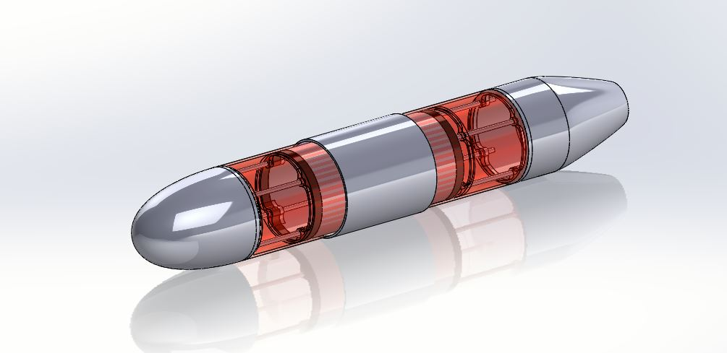

Fig 1: CAD model of the bot.

**CONTROL OF THE MECHANISM:**

The submarine contains a fixed cylinder shell which has two stepper motors attached at both the ends and the motors rotate a square threaded shaft. There are two movable shells which moves over the fixed cylinder. these movable shells contain a lead screw in the center through which the threaded shaft rotates. So when the threaded shaft rotates, due to the lead screws the two shells starts moving in either directions in the longitudinal axis. This keeps the center of mass unchanged and can change the volume of fluid displaced by the submarine.

**Collection of data:**

Collection of data shall take place while the bot is present inside the water body where neutral buoyancy has been achieved the robot then covers the entire trajectory inside the water body itself taking the samples at different locations or different time intervals as assigned earlier. The chamber is shown in fig2.

It has multiple compartments. One is the large compartment where water at the given point is sucked in. Sensors are also placed in this compartment to check the water quality. It is proposed to check six parameters which include dissolved oxygen, ammonia content, salinity value, pH of the water, the pressure at that point, the temperature of the water at that point of time. The sensor data is analysed and logged in memory.

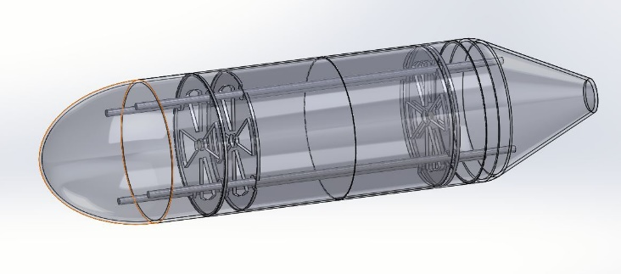

Fig 2: Data storage chambers

The big chamber is connected to multiple smaller chambers below it where the portion of samples is stored as per location geometry. Once the measurement is over, a small solenoid valve is opened to pass water to the bottom chamber. Further, this valve is closed and the remaining water is drained out. It does a similar action in each point and every point water samples, as well as corresponding data, are stored at their respective places.

The bot comes up and transfers this data through the LoRA communication link to the post. It marks the data with GPS. The Sensor data and collected samples are collected at the shore after the completion of the journey of the bot.

**The trajectory:**

The trajectory is chosen to have either a rectangular path or a circular path. The robot starts from a point where a predefined location is sent to the robot, and it starts moving from that point completing a full rectangle or a circular path and collecting the data at the same time at different intervals of the time under the water. Once the trajectory is completed the bot automatically floats over the surface and comes back to the starting location. A control algorithm will be developed to provide the required turns at different points to cover the entire area.

**The sensors:**

Two types are sensors are used.

1. Control sensors
2. Measurement sensors for water quality check

Control sensors are Gyroscope and accelerometers give rate and position parameters for maintaining the trajectory and vehicle stability. The position data is also updated by GPS.

Measurement sensors  are used for dissolved oxygen levels, salinity level,  pH levels ,ammonia content, temperature of the water and  pressure at the point.

**The Computation element:**

A RASPBERRY- pi3 controller is used as processing hardware. All sensors and actuation devices are interfaced with this controller. It has also been provided to log data. The software will be developed in python /C language. The software has the following modules.

1. Water pump controller to collect water to sink the vessel.
2. Stepper motor to expand the bot to move up.
3. Control algorithm to maintain the trajectory of the vessel at the pre-calculated spot.
4. Actuation of propelling motors to provide thrust in forwarding direction.
5. Operation of a small pump to collect water samples.
6. Initialize all measurement sensors. Collect data from sensors and process them.
7. Store data in a zip drive. Such that it can be recovered easily at the shore.
8. Open solenoid valve of required chamber of sample collection to store samples to be collected at shore for detailed investigation.
9. Collect data from GPS as marking point.
10. Transmit data through the LoRA modules.
11. Transfer all data through communication link at shore.\

5.6 GPS and Communication module

GPS and communication antenna is placed on top of the bot. A Patch antenna for GPS and a whip antenna for LoRA communication is planned. The Lora module is connected to RPi through SPI link.

1. **Application:** There are numerous applications for this task. They are given below.
2. Survey of water bed from river, lakes or pond for the primary investigation of water quality. This may be suitable for the clean Ganga project.
3. Survey of water to alert danger situation for fishes.
4. Survey of Sea and Ocean to reach benefit to the fisherman to locate a correct fishing spot
5. Finding and rescue tasks underwater during disasters such as floods and Tsunamis.

**Further work**

The idea is formulated by a group of students which are further discussed and deliberated by the concerned faculties. The work will find a boost in case of acceptance of the internal project. The task is unique and will open up many directions in the future. There are many DST, AICTE, UGC sponsored projects related to water management. Since the topic is new in concept, there can be the generation of papers and patents.

**Quick process of what is done.**

The robot dives into the water taking in various readings such as dissolved oxygen, pH, and barometric pressure. It processes that information and gives a probability of where the maximum number of fish could be found. So initially we choose a starting and that’s all you need to do. The rest is handled by the vehicle. It dives 5 meters into the water body and travels in straight lines to form a rectangle. It stops at, every corner of the rectangle to collect water samples and pictures of the area and analyse values. Once it collects the sample it turns and moves towards the next vertex. It does this ‘N’ times, thereby completing a rectangle. It analyses the values to form a probability distribution which it displays to the user understandably. This helps the authorities Know the location of people or things that are trapped underwater and they are identified and rescued.

**Abstract:**

**Theme:**

Industry

**Title of the project:**

Ksheera

**The Problem**:

The problem statement we have selected is that people who are in the fishing industry or who go fishing find it difficult in knowing the exact location or approximate site of the best fishing (high quantity and quality fish(swordfish, tuna fish, etc)) so that the time of being at the fishing location could be used more effectively and productively.

**The team’s approach to solving the problem**:

1. Our idea is to build a network of robots that moves inside the sea or ocean wherever the fishing is done in a specified area with the basic knowledge and get the data (microplastic concentration, pH, temperature, dissolved oxygen, etc.) of conditions of the ocean or sea, analyse the data and compares with the data which favours the fish and suggests the best area of fishing.

2. The design is chosen to be streamlined, as it makes the Robot move       efficiently inside the water body.

The bot is equipped with four thrusters two present on the sides for the movement of the bot to move on the x and y-axis and for the movement on

the z-axis the bot uses the concept of neutral buoyancy to move wherein

There are two chambers present within the robot. The two chambers are equipped with 2 pumps which take water for the moment of the bot in the negative Z-direction and attain neutral buoyancy with the amount of water taken in, making the density of the robot equal to the water and remaining stable at that position at a depth of 5 meters, for the movement in the positive Z direction, the bot expel out the water which was taken in earlier making the bot lighter than the water to move towards the surface of the water.

There are 2 more thrusters present on the bot which take in information from the   Gyroscope and accelerometer for maintaining the trajectory of the robot and attenuating the disturbances caused in the water body, thus making the robot complete the trajectory without changing the initial and final mapped points.

Name: Vineeth Yelagandula, P Sai Krishna, Bhuvan Pratap Agarwal, Vishnu Vardhan Julakanti , M Srinath , M Sai Praneeth, Dr. D Ajitha, Dr.Joydeb Chattopadhyay

Designation: Inventor

Date: